Knowledge Base Article: Responding to Unwanted Software Download Alerts in Microsoft Defender for Endpoint

Overview
This article outlines the steps for investigating and responding to an alert indicating that potentially unwanted software (PUP) was downloaded on a user machine. The process involves alert review, file reputation checks, forensic analysis, machine isolation, threat hunting, and containment actions to mitigate the threat.

Incident Response Steps
1. Alert Review and Initial Assessment
Upon receiving the alert that potentially unwanted software was downloaded, follow these steps:
- Access the Alert: Open the alert in Microsoft Defender for Endpoint under the "Incidents & Alerts" section.
- Review Alert Details: Examine the alert severity (High, Medium, Low), category, and affected devices. Review the process trees and timestamps to understand when the suspicious activity occurred and identify which processes were involved.
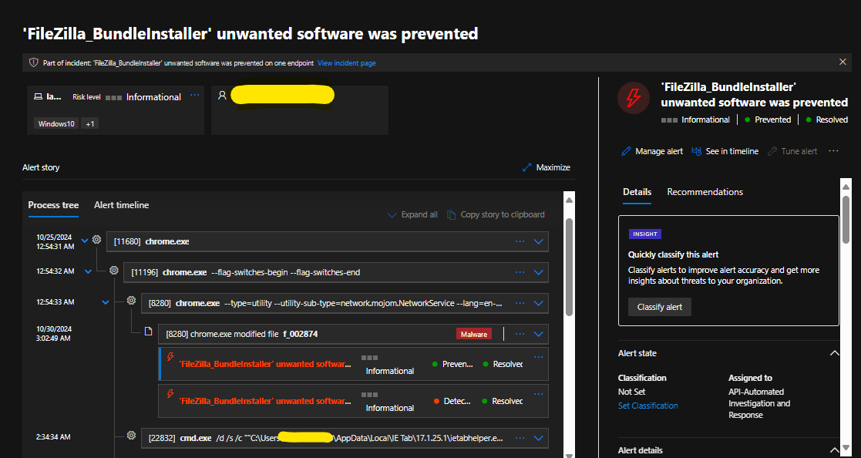

2. File Reputation Check
Before proceeding, it's important to verify whether the flagged file is known to be malicious:
- Check File Reputation: Use tools like OSNITs, VirusTotal, or other reputation services to check if the file has been flagged as malicious or potentially unwanted by other security vendors.
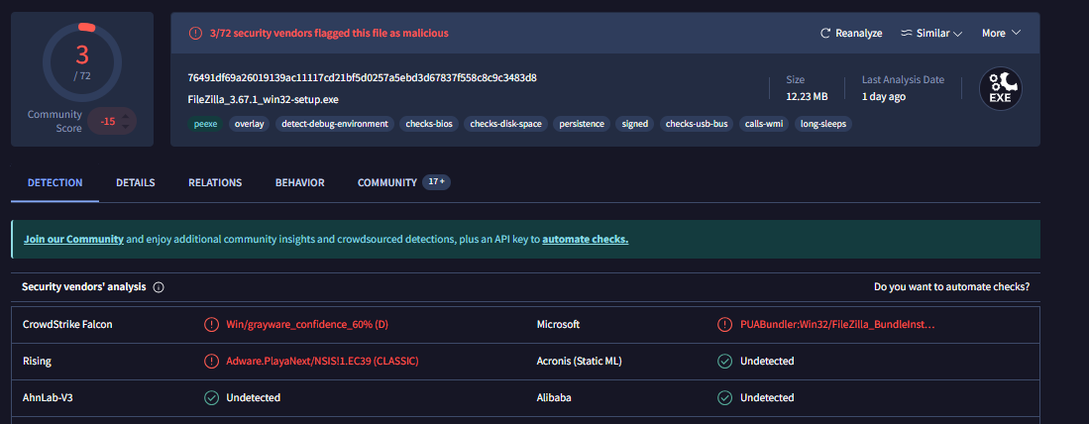
3. Timeline Review and Suspicious Activity Investigation
Next, investigate the activity surrounding the affected device:
- Review the User Machine Timeline: Look for suspicious activity, including signs of lateral movement, abnormal network activity, or unauthorized file/registry modifications. This helps in identifying whether the threat was part of a larger attack or localized to the affected machine.

4. Machine Isolation and Remediation
If the file is confirmed to be malicious or suspicious activity in timeline, take immediate action to contain the threat:
- Isolate the Affected Machine: Disconnect the machine from the network to prevent further spread of the threat.
- Remove the Malicious Software: Kill the suspicious process and remove file immediately.
- Quarantine the Software: Quarantine the flagged file to prevent it from executing further.
- Initiate Additional Remediation: Reset the user’s password to ensure their account is secure. Clear the browser cache to eliminate any potential stored malicious data.
5. Blocking the File and Network Mitigation
To prevent future incidents, further containment actions should be taken:
- Block the File Hash: Block the file hash (MD5, SHA1, SHA256) across the network to prevent the same file from being executed again.
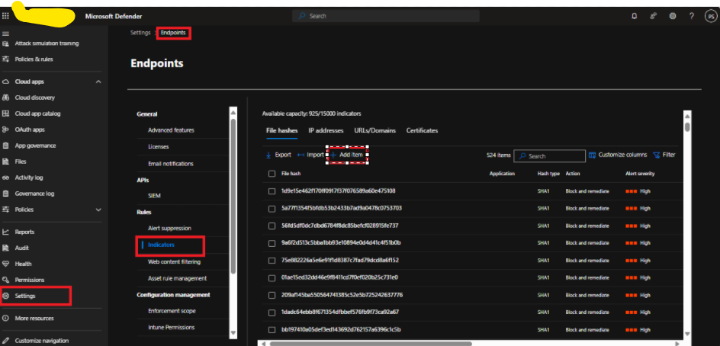

6. Threat Hunting Using the File Hash
To determine if other devices are affected by the same potentially unwanted software:
- Perform Threat Hunting: Use the file’s hash (MD5, SHA1, or SHA256) in Advanced Hunting queries within Microsoft Defender for Endpoint. Search across your network for any other devices that might have the same file hash or any related indicators of compromise (IoCs) to identify if other machines are also affected.
- Investigate Additional Devices: If any other devices are identified as potentially impacted, perform the same investigation and remediation steps on those machines.
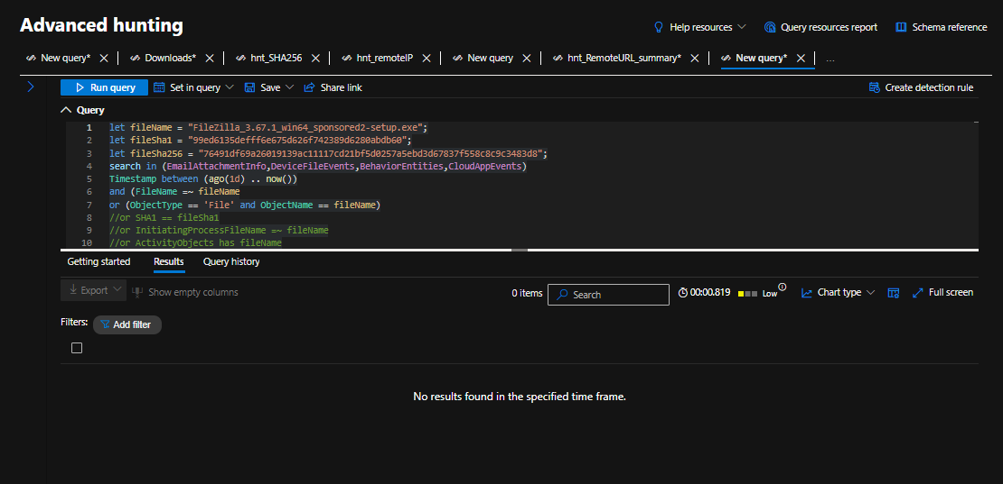

7. Forensic Analysis and Intrusion Investigation
Perform a deeper investigation to understand how the file entered the system:
- Examine User Activity: Investigate how the file was downloaded or executed. Did the user unknowingly download it from a website, click on an email attachment, or install it via a USB device?
- Determine the Method of Entry: Review whether the threat came from the web, an email, or another external source.
- Block Websites or Emails: If the file was downloaded from a website, block the website at the indicator and network level. If the file came via email, block the email address and purge all related emails associated with the malicious attachment.
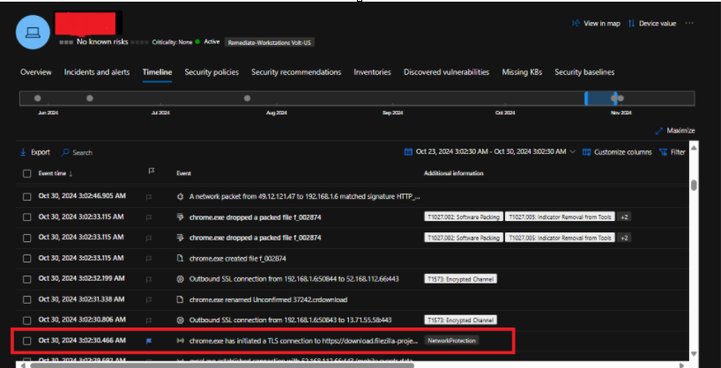

8. Final System Check and Confirmation
Once remediation actions are complete, ensure the machine is fully cleaned:
- Run a Full System Scan: Perform a full system scan on the affected machine using Microsoft Defender to detect any other threats.
- Confirm Remediation: If no further threats are found, confirm that the system has been successfully remediated and is free from malicious activity.

